EXP 14 V2X Latency Comparison
AIM :
To simulate and compare the latency performance of DSRC, C-V2X, and 5G NR V2X technologies by modeling propagation, processing, and queuing delays across multiple vehicles and time slots.
THEORY :
Vehicle-to-Everything (V2X) communication relies on low-latency wireless links for safety-critical applications such as collision avoidance and cooperative driving.
Different technologies exhibit different latency characteristics: DSRC offers moderate latency, C-V2X provides improved reliability but with slightly higher delay, while 5G NR V2X is designed for ultra-low latency through advanced radio access and network optimizations.
Latency in V2X arises from multiple components including propagation delay, processing delay, and queuing delay, each contributing to overall end-to-end response time.
PROCEDURE :
- Define the number of vehicles and time slots to be simulated.
- Set mean and standard deviation values for latency for DSRC, C-V2X, and 5G NR V2X.
- Generate latency values for each vehicle and time slot by adding propagation, processing, and queuing delays.
- Ensure total latency remains non-negative.
- Store the simulated latency for all technologies.
- Compute average latency across time slots for each technology.
- Plot average latency vs. time slot for DSRC, C-V2X, and 5G NR V2X.
- Display overall average latency for each technology in the command window.

PROGRAM :

clear; clc; close all;

%% PARAMETERS
num_vehicles = 10; % Number of vehicles
num_slots = 20; % Number of time slots/messages

% Latency parameters: mean ± std (ms)
latency_params = [1 0.2; % DSRC
2 0.5; % C-V2X
0.5 0.1];% 5G NR V2X
tech = {'DSRC','C-V2X','5G NR V2X'};

latency_all = zeros(num_vehicles, num_slots, length(tech));

%% SIMULATE LATENCY
for t = 1:length(tech)
mean_delay = latency_params(t,1);
std_delay = latency_params(t,2);
for v = 1:num_vehicles
for s = 1:num_slots
prop_delay = mean_delay + std_delay*randn;
proc_delay = std_delay*randn;
queue_delay = rand*0.5;
latency_all(v,s,t) = max(prop_delay + proc_delay + queue_delay,0);
end
end
end

%% PLOT AVERAGE LATENCY
figure; hold on; grid on;
colors = {'b','r','g'};
for t = 1:length(tech)
plot(1:num_slots, mean(latency_all(:,:,t),1), 'LineWidth',2, 'Color', colors{t});
end
xlabel('Time Slot');
ylabel('Average Latency (ms)');
title('V2X Latency Comparison: DSRC vs C-V2X vs 5G NR V2X');

% Add legend
legend(tech,'Location','northwest','FontSize',10,'FontWeight','bold');

%% DISPLAY AVERAGE LATENCY
disp('Average latency per technology (ms):');
for t = 1:length(tech)
avg_lat = mean(latency_all(:,:,t),'all');
fprintf('%s: %.2f ms\n', tech{t}, avg_lat);
end
OUTPUT :
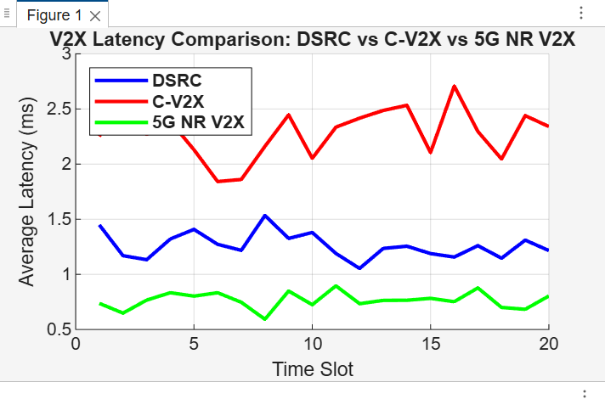

CONSOLE OUTPUT :
Average latency per technology (ms):
DSRC: 1.26 ms
C-V2X: 2.29 ms
5G NR V2X: 0.76 ms
>>

CONCLUSION :
5G NR V2X shows the lowest latency compared to DSRC and C-V2X, making it most suitable for ultra-reliable and time-critical applications.C-V2X provides moderate latency with improved stability over DSRC but does not match 5G’s performance.
Overall, the simulation confirms that 5G NR V2X delivers superior real-time responsiveness for future intelligent transportation systems.

